# notes

|  |  |  |
| --- | --- | --- |
| Patent invention |  |  |
| Plastic  Metal  3D printer | /ˈplæstɪk/ /ˈmet(ə)l/ |  |
| Off the chart  Overpass the level,  Better than good |  |  |
| Game:  Assasins creed |  |  |
|  |  |  |
|  |  |  |

## lesson

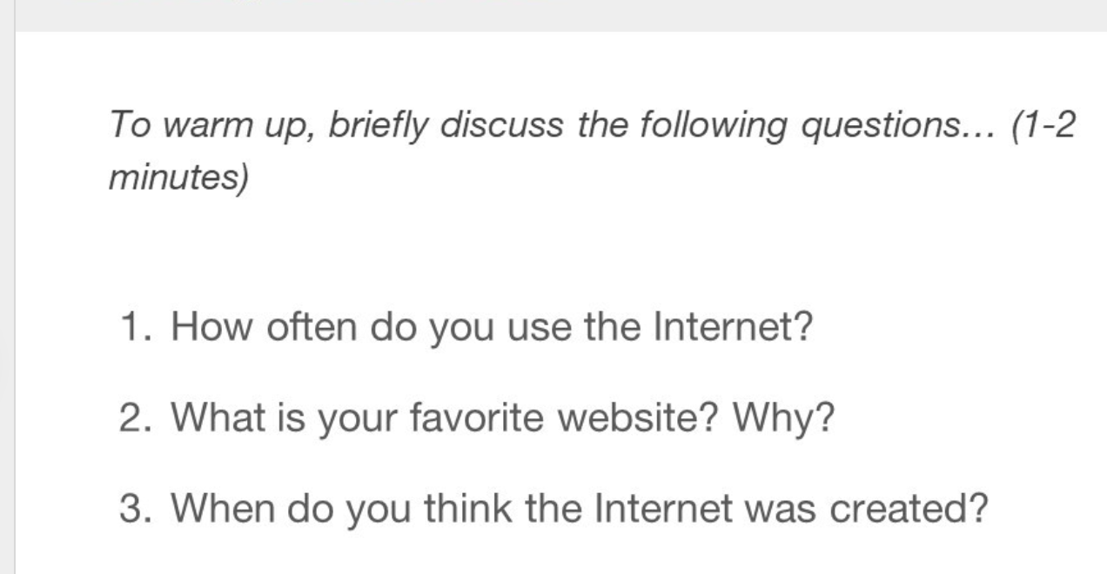

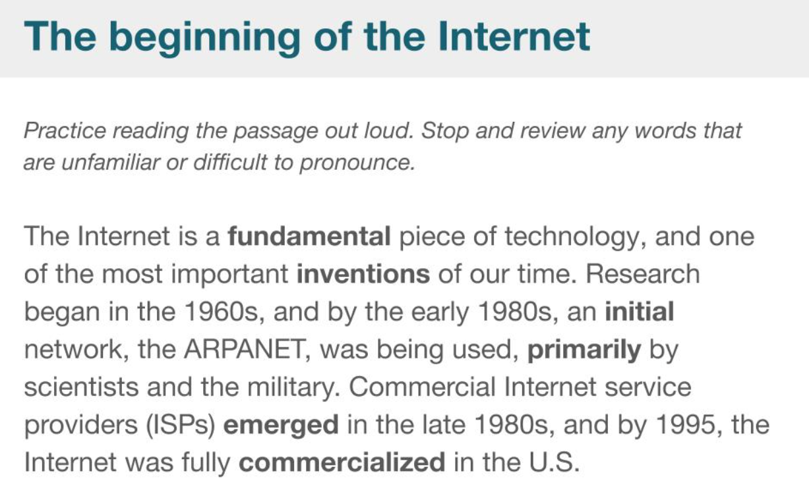

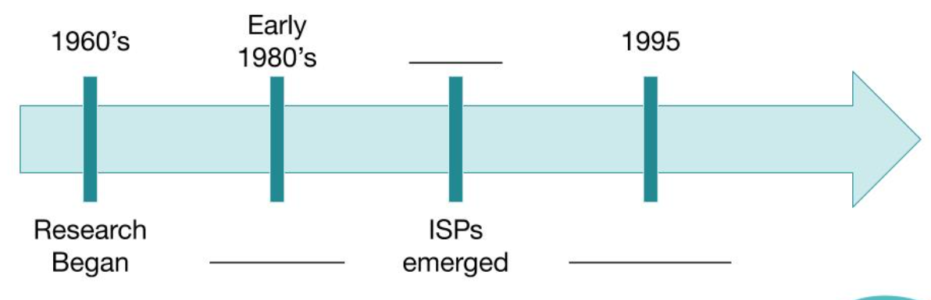

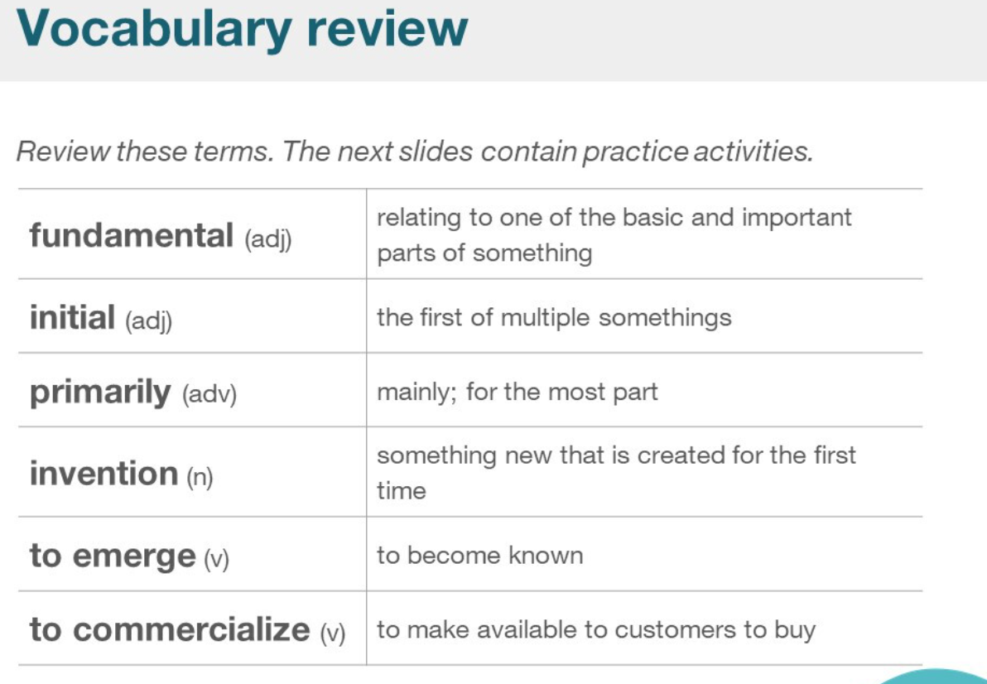

|  |  |  |
| --- | --- | --- |
| fundamental | /ˌfʌndəˈment(ə)l/ |  |
| initial |  |  |
| primarily | /praɪˈmerəli/ |  |
| invention | /ɪnˈvenʃn/ |  |
| To emerge | /ɪˈmɜːdʒ/ |  |
| To commercialize | /kəˈmɜːʃəlaɪz/ | Com-mer-cia-lize  Commercialize housing |

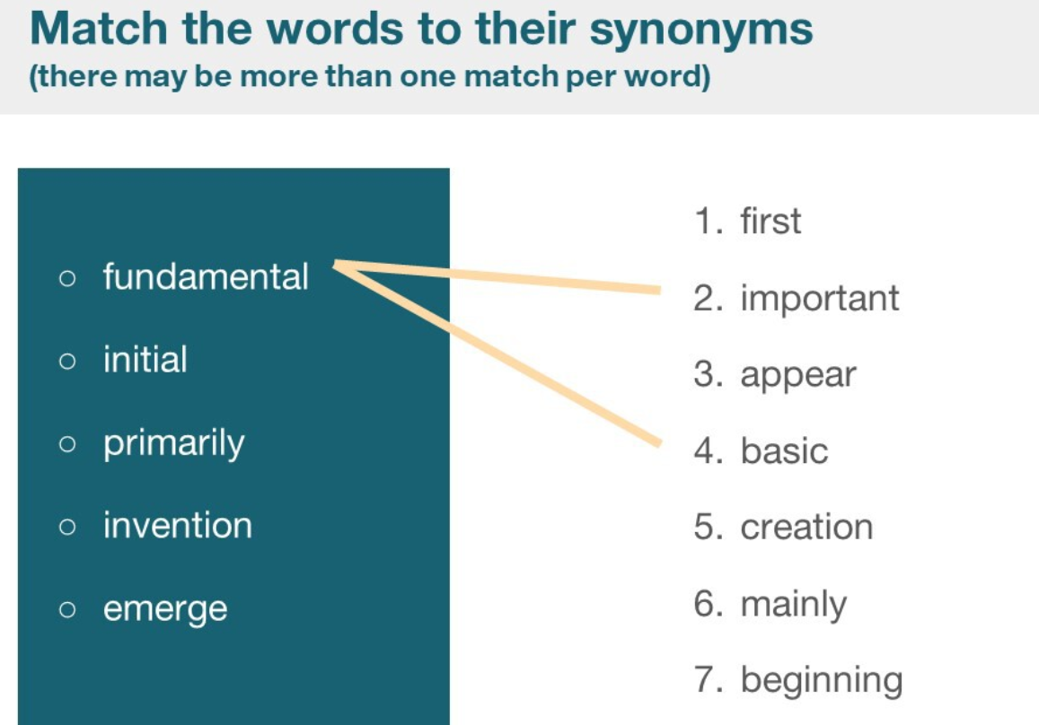

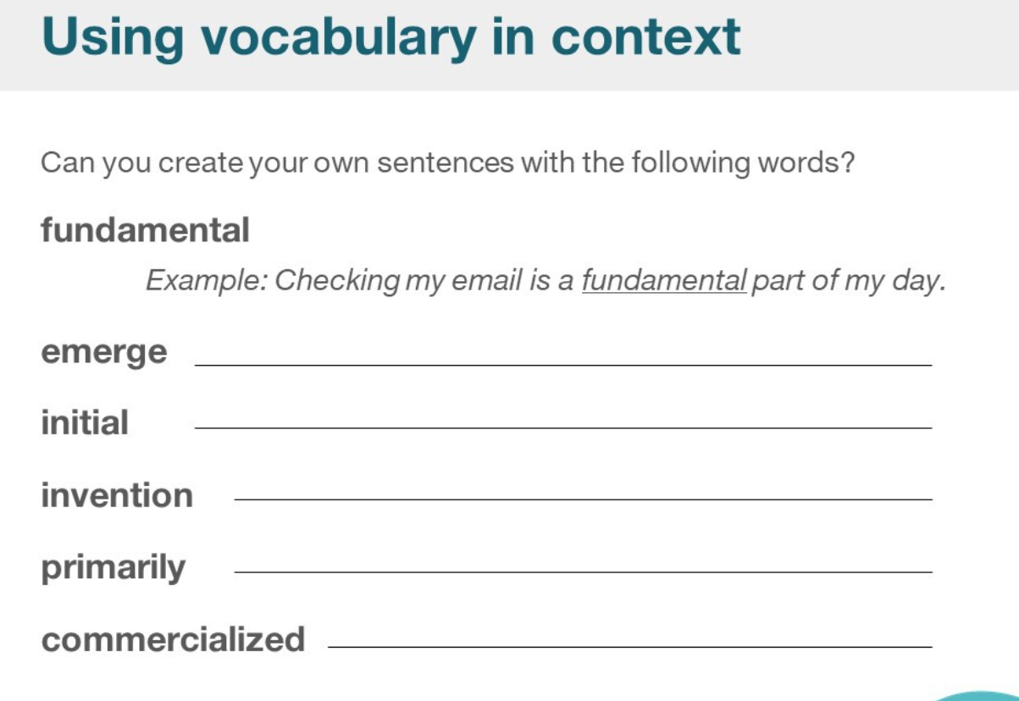

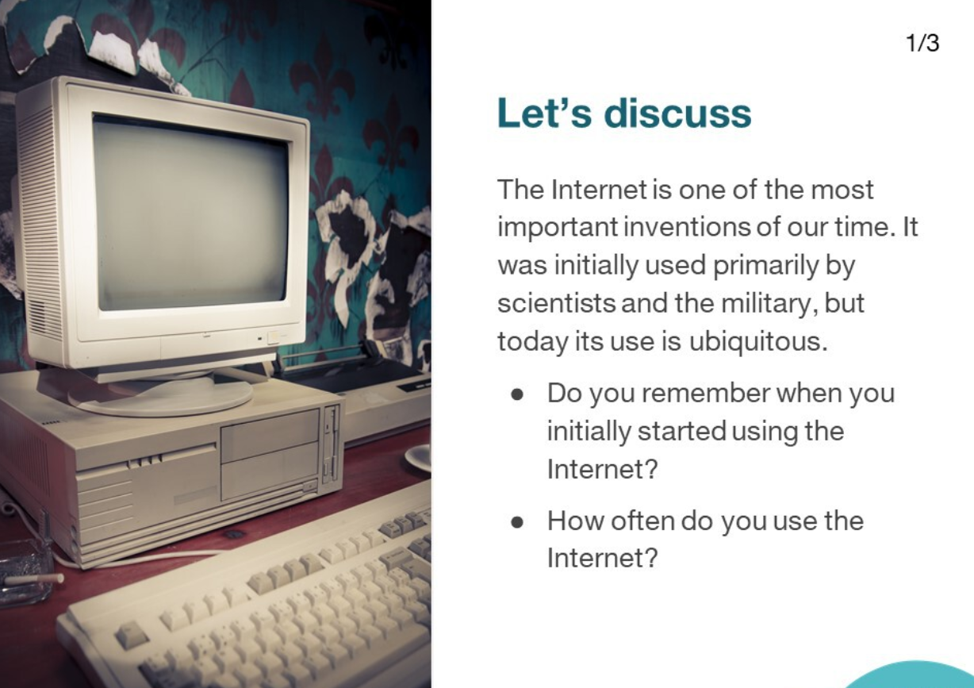

|  |  |  |
| --- | --- | --- |
| Scientists  military | /ˈsaɪəntɪsts/   * ˈmɪlətri/ |  |
| Ubiquitous  Common  General | /juːˈbɪkwɪtəs/ |  |
|  |  |  |

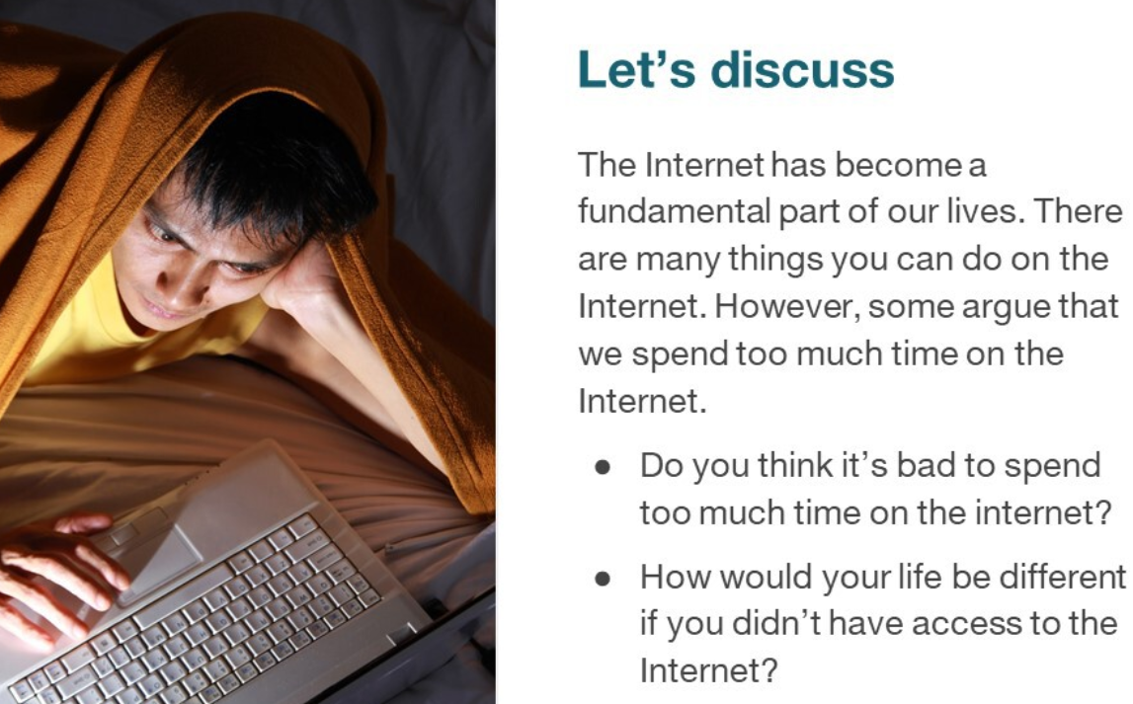



|  |  |  |
| --- | --- | --- |
| Internet security |  |  |
| Global concern |  |  |
| Protect  threat |  |  |

